LUDINGTON AREA SCHOOLS
FOSTER ELEMENTARY SCHOOL

Brian A. Dotson
Principal

August 17, 2018

Dear Foster Elementary Families,

It is my pleasure to welcome you to a great year at Foster Elementary School. We are all excited to have students back in our classrooms and hallways filling them with energy and enthusiasm for learning. It is our mission to provide a secure learning environment, which will foster a positive self-image and challenge academic abilities, while promoting a lifelong commitment to learning.

Remember to utilize our district and school webpage, www.lasd.net, for updated and current information. The website has many great features including: staff contact, important dates, curriculum information and programs/services. Additionally, you can follow the Foster School PTC Facebook Page “Ludington Foster School PTC,” which sends out updates and quick announcements as we go through the school year. Last year, I started an additional Facebook page, “Principal Dotson,” feel free to follow me for fun updates throughout the year. Secretaries are back in the office between 8am-3pm until the start of school. If your child takes medication during the school day, it can be dropped off after that date; beat the rush!

I am honored to serve once again as the principal of Foster Elementary School. It is truly a privilege to be part of a community where parents, teachers and students care for each other and strive to build positive relationships that support academic and social growth together. Please feel free to contact me at (231) 845-3820 or by email bdotson@lasd.net if there is something I can assist you with.

I look forward to meeting you at our Meet the Teacher night on Wednesday, August 29th at Foster Elementary School. 3rd grade is from 5:30-6:30pm, 4th & 5th grades are from 6:30-7:30pm. At this event, you and your child will be able to meet their teacher, and staff to learn useful information to help make this school year a success. This will be a different evening than what we’ve had in the past. There is no formal presentation in the gym or with the teachers, it’s simply a meet and greet with information available. We look forward to seeing you at this event. We will have a more formal Back to School night with presentations on Wednesday, September 19th, 3rd grade 5:30pm and 4th and 5th grade 6:30pm. More information to follow.

On the back of this letter is a reminder of student drop-off and pick-up locations. Please know that drop off should occur after 7:35am. School hours are the same as last year: Foster Elementary STARTS at 8:05am and ENDS at 3:20pm. A half day STARTS at 8:05am and ENDS at 11:46am.

Once again, welcome back! Together let’s make it a great year at Foster Elementary School!

Sincerely,

Brian Dotson
Foster Elementary School Principal

Drop off & Pick up Information!

Morning drop-off (7:35am at the earliest) and afternoon pick-up (3:20pm) by parents will be done on the west side of the building along Lavinia Street.

During the afternoon pick-up, more parents arrive at the same time, causing more congestion to traffic patterns around our building. Lavinia Street, the street on the west side of the building, is designed to be a parent pick-up area. There are twelve spaces along the school side length of this street. Please do not use these spaces for long-term parking if you want to go into the building.

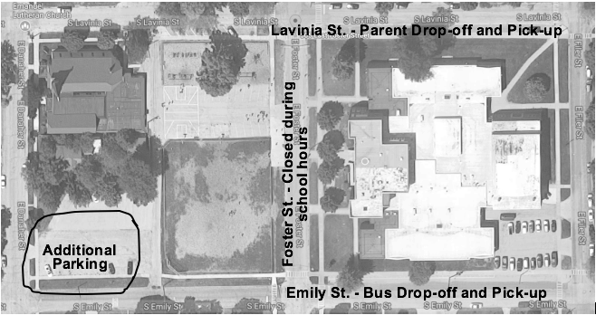

Emily Street, along the east side of the building, will again be used for bus drop-off and pick-up. Please avoid this area for the safety of the children during drop-off and pick-up times.

Foster Street, along the front of Foster Elementary School, is barricaded closed during school hours for safety measures, as it is part of the school playground

The City of Ludington has prohibited parking on the school side of Filer Street. In the event you want to park and pick up your child at the end of the day, the best place for this is the 50+space parking lot just south of the playground backstop. We share this lot with Emanuel Lutheran Church. The field is a perfect spot to meet your child after school. Be sure to communicate to your child your end of the school day dismissal plan!

